Curbing the spread of micro-plastics by detection using deep learning.
Abel Rono
In13/00026/20

Abstract.
Plastic mismanagement have been a menace in the recent years. Increase production of the plastics and its usage have been one of the reason for the increase of the plastics. The evolution of the plastics in water cause by factors such as biological degradation or chemical degradation have resulted to a yet deadly micro-plastics. Several ways have been set aside to compact the same, this ways are have yield little results. In this proposal, a computer vision model is proposed to detect micro-plastic on water surface. Different image pre-processing techniques are used to transform the raw image data to a meaningful data to train the model. The algorithm used to train the model is YOLOv8 a single stage object detector. The performance of the model are satisfying with a precision of 1, recall of 0.88 and f1 score of 93%. The proposed model is trained using a dataset containing bounding boxes coordinates, this coordinates highlights the areas the objects is located in the image. This coordinates are normilized by finding the y center and x center.

1. Introduction.
Plastics are generally used in every sector be it manufacturing, health care sector. This has led to the increased production of plastics with an estimate of about 150 million per annum according to Ali Reza et al (2017). Though most of the plastics are recycled, a lot of virgin plastic are produced which accumulates to an estimate of about 8300 million metric tonnes produced to date (Roland et al 2017).
One of the issues that has led to increased production of plastics is mismanagement of the plastics which now finds way to the water bodies posing danger to the habitat. This has led to plastics being the leading pollutant of water bodies.
Through time plastics have disintegrated due to factors like biological factors or chemical factors, Monika et al (2023), this has posed another challenging issue of micro-plastic which are small in size of less than 5 mm which is more deadly to the aquatic life as they can be ingested by even smaller aquatic invertebrates this causes effects to the danger to the aquatic creatures. These effects are through oxidation stress (Luca et al 2019).
According to Sajjad et al (2018), most aquatic life especially fish being edible to human beings, this micro-plastic has found its way to the human bodies as a result as humans are exposed to synthetic material.
Over the recent years there have been ways to curb the increasing amount of plastics and micro-plastics in water bodies; these are termed as traditional ways which includes; survey methods. These methods lack quantifications which has prompted researchers to alternative ways.
These current methods often involve researchers using different methodologies for different environments preventing effective comparisons. This limits the strength of evidenced based recommendation to support policy changes regarding the mitigation.
The most current method has been combining cameras either aerial or cameras mounted on automotive with computer vision technologies to optimize detection and classification of plastics or micro-plastics.
This study contributes to the following aspects;
- Using the current deep learning framework for fast detection with favorable accuracy. In this study, the YOLOv8 framework is used to train the model. This framework has proven to be powerful compared to other deep learning techniques and previous yolo frameworks.
- Analysis of the previous studies for detecting micro-plastics in water.

2. Related works
Computer vision for compacting micro-plastics in water has developed significantly in recent years. These models have been developed using different techniques and methodologies with significant results.
According to Carmine et al (2021), it is possible to automatically count micro-plastics and divide them into groups with considerable time saving based mainly on the early machine learning algorithm. The paper presents a method to count and classify micro-plastic particles.
Abundance of plastics has led to inadequate disposal of plastics which by time degrade yearly to micro-plastics causing a menace in water bodies. Determining the abundance of micro-plastics using image processing has a great potential compared to visual inspection (Crislaine et al 2021).
Quantification of micro-plastics has been a labour yet a critical task for a safe environment and good health. (Bin shi et al 2022), used a deep learning approach of quantifying micro-plastics. The model proposed used annotated image data and instance segmentation was performed using MultiResUNet and U-net 1 frameworks with performance of 85% accuracy of both models.
The efficiency and reliability of machine learning and computer vision algorithms in detecting or classifying micro-plastics solely depends on aspects such as data collection, image data preprocessing and their techniques. These aspects are important for the models to perform efficiently (Jimming Su et al2023). The application of these algorithms depend on different scenarios such as classification, detection or segmentations.
The existing neural networks such as multi-Resnet and U-net 1 perform poorly in classification of micro-plastics , the results of f1 score of 40% and precision of 25% in segmentation, this is caused by most of micro-plastics lacking shape making it hard for the models to identify them (Gwanghee et al 2021). The use of improved versions of neural networks will yield significant results.
The YOLO framework has been tremendous in recent years. According to Ekerm et al 2022, designing a classification system with a success rate of 98% using YOLOv4 and 100% USING YOLOv5 has shown how the current development of neural networks has increased in classification tasks. Though the dataset used was a result of the wavelength of the different images it has proven itself to be efficient.
An ensemble approach for micro-plastic identification using fourier spectrum ( Xing et al2022),evaluation of different machine learning algorithms in identification of micro-plastics indicated that an imbalanced dataset has a fouling effect on the performance of the algorithm.
Applying pipeline schemes to avoid bias in the training and selection phases (Henrique et al2022), this bias is caused by imbalance in the dataset. Fixing the issue of dataset imbalance in deep learning networks has not been properly explored, (wei et al2016), using the loss function proposed outperformed MSE, the commonly used method of handling imbalance data in neural network structures. Data augmentation has also been one of the techniques to fix the issue of imbalance data (Seong-eun et al 2021), a diverse augmentation policies were applied to the base model in sequence and the optimised policy suitable for training data were strategically selected through the gradient-based performance improvement rate. With performance metrics of 90.5 accuracy.

3. METHODOLOGY.
3.1 Data preprocessing
This is a fundamental step in designing a computer vision model. Here different techniques are used to transform raw data to meaningful data that can be used to train the algorithm and for the model to yield satisfying results.
3.2 Dataset.
The dataset used contained 781 images and their respective annotation file in csv format. The source of the dataset was from kaggle. The dataset contained training set and validation set. The training folder contain 577 images and the validation dataset contain 204 images. The training folder and validation folder has annotation csv files in their folders respectively. The image data only contains one class that is micro-plastic.
3.3 Conversion of RGB to Grey Scale.
Converting RGB images to grayscale is one of the important steps in data preprocessing. It constitutes dimension reduction, RGB images have 3 channels while gray scale has 1 channel. RGB images when used in developing neural network models adds more input layer nodes as it contains 3 color channels the input layers will be added to 300 nodes compared to grayscale images which will use 100 input layer nodes.

3.4 Image noise and de-noising.
The noise present in grayscale images is impulse noise which includes salt and pepper noise.
Also called data drop-out.
It is a fixed valued impulse noise. This has only 2 possible values (for 8-bit image) that is 255(bright) for salt and 0 (dark) for pepper noise. Sources of this noise is through; sharp and sudden disturbances in the image signal and malfunctioning of camera’s sensor cells.
Median Filter is one of Non-linear filters, which is also used for smoothing. Its basic idea is to replace each pixel by the median of its neighboring pixels (pixels in the window).
By doing so, it removes some spikes introduced by noise: especially impulse and salt & pepper noise. This is because stand-alone noise pixels with extreme intensities like black and white cannot survive after median filtering. Another advantage of the median filter is that it does not introduce new pixel values since it only re-use existing pixel values from the window.

3.4 Normalization.
The annotation file contains bounding so there coordinates are normalized by finding the;
[X_center, Y_center, width, height]
Where;
X_center and X_center are the normalized coordinates of the center of the bounding box and width, height are the normalized width and height of the image.
The annotation format of yolov8 used to develop this model is:
[Class_idx Norm_(Xmin) Norm_(Ymin) Norm_(W) Norm_(H)]
The Class should be a unique integer value, i.e. the sequence from 0 to n,
The coordinates of annotations are (Xmin,Ymin,Xmax,Ymax) where,
(Xmin,Ymin) = (X1,Y1)
(Xmax,Ymax) = (X2,Y2)
The normalization formula,
Normalized(Xmin) = (Xmin + w/2)/image_width
Normalized(Ymin) = (Ymin + h/2)/image_height
Normalized(w) = w/Image_width
Normalized(h) = h/Image_height
The normalized coordinates are stored in a text file that yolov8 algorithm will use to perform detection. Yolov8 takes the normalized images that is the center of the bounding boxes which are saved in YAML text file. It takes this text file to perform detections.
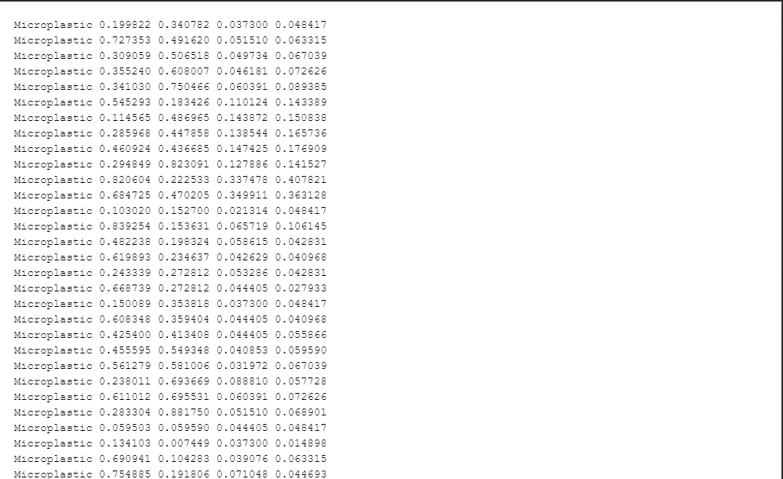
Figure 1 normalized bounding boxes coordinates.
3.5 Algorithms.
The algorithm used in this is yolov8 from the YOLO series of algorithms. It is the newest algorithm for detection and classification. Yolov8 was used in this model because of its performance since it is faster compared to 2 stage object detection and also maintains higher accuracy than previous YOLO algorithm series.
Yolov8 takes image size up to 640. The batch size and epoch are also entered during training of the model. High batch size and image size improve the accuracy of the model as the model will be able to generalize the inputs images. Though, increase in the above batch and image size improve the accuracy it also depends of the computer hardware components such as GPU.

3.6 Architecture.

Input Image
Backbonee
Backbone
Backbone
Neck
Neck
Neck
Head
Head
Head

Feature extraction multi-resolution image detection
Aggregation
Figure 1. Model architecture
Backbone Network: This is component is the foundation of the framework. It uses a ResNet-50 deep convolution neural network (CNN) to extract features from the input image.
Neck Network: This component connects the backbone network to the head network. Its role is to reduce the size of the feature map and increase the resolution of the features. The neck network is designed to find a balance between accuracy and speed, making YOLOv8 both fast and efficient.
Head Network: This is the component that predicts the class and location of objects in the image. It uses anchor boxes to estimate the object location and class scores. The head network is trained to optimize the Intersection over Union (IOU) between the predicted and ground-truth boxes. It also includes the non-maximum suppression (NMS) algorithm, which filters out overlapping bounding boxes and ensures that only the most confident predictions are output.
Model architecture depicts the data flow through the computer vision tasks. It provides layers connections and components.

3.7 Evaluation metrics.
F1 Score.
This is a harmonic man of precision and recall. F1 score provides a comprehensive evaluation of the model performance.
Formula,
F1_score = 2(precision recall)/ (precision + recall)
Recall.
Measures the ability of the model to detect positive samples in the dataset. A high recall value indicates that the model is correctly identifying a large proportion of the relevant samples in the dataset. Recall is an important metrics application where it is important to identify as many positive samples as possible.
Formula,
Recall = True Positive/ (True positive + False negative)
Precision.
Is a performance metric used to measure the accuracy of positive predictions. It represents the proportion of true positive predictions out of all the positive predictions made by the model.
Formula,
Precision = True Positive/(true positive + false positive)

3.7 Quantitative and qualitative.
The qualitative analysis visually compared the noisy image original image and de-noised image. In noise reduction, the preservation of image details is preserved, the noise is removed to make the image clearer and smoother. Additionally the image still depicts a similar structure and pattern compared to the original image.
The qualitative analysis for de-noising micro-plastic images is demonstrated in the figure1.
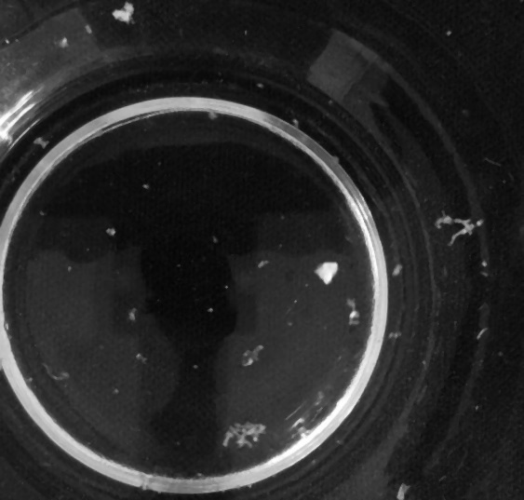
- Original image 35% noise
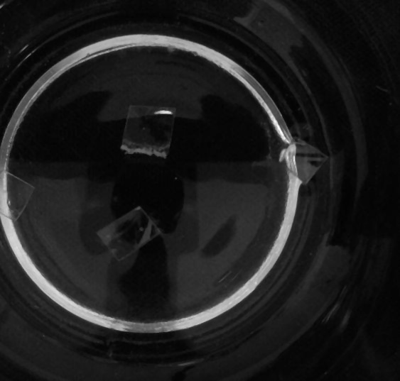
- De-noised image.
The original image in (a) had a noise variance of 30 % it was subjected to median filter a de-noising technique and the result (b) which looks clearer and smoother.
Quantitative analysis.
The proposed model underwent a subjective analysis approach. Peak signal to noise ratio was for evaluation.
Peak signal to noise (PSNR0 is the ratio between the maximum possible power of an image and the power of corrupting noise that affects the quality of its representation. The larger the value of PSNR, the more efficient a corresponding compression or filter method.
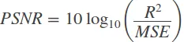
Where, R represents the maximum range of the data. For an image, which is usually 8 bit, the maximum value is 255 while the minimum is 0. Then the value of R is their difference, that is, 255. PSNR is always define in decibels (db) and hence we take the logarithm of the ratio.
Median filter proved to be effective in denoising of the images as the peak-signal-to-Noise-ratio value of the denoise image is 41 decibels. Median filter is robust against outliers in the data and is therefore suitable for images with impulive noise.
4. Discussion.
Model had a recall value of 0.88 at intersection 0.00. This indicated that the model was able to identify large proportion correctly of the micro-plastics in the dataset.
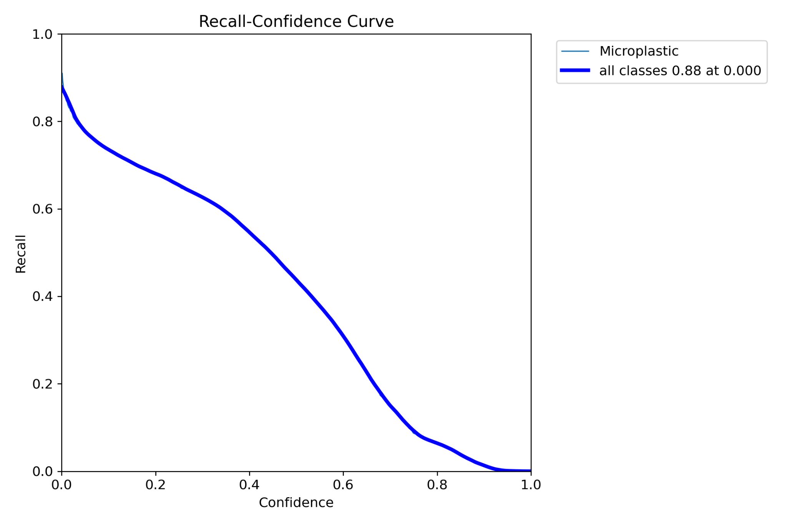
Precision
The model was able to accurately represent all the images with micro-plastic those with not positively with 100% positive predictions. As show below:
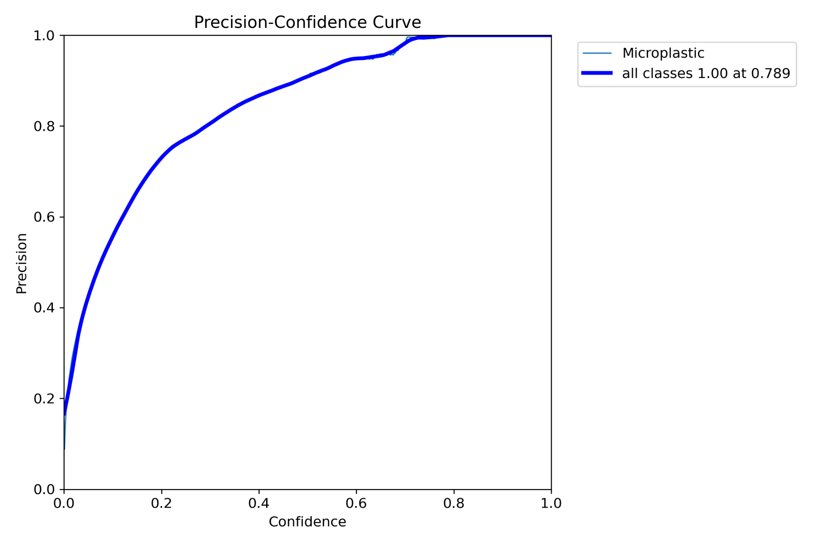
Performance of the model on the training data.
The following image depicts how the model identified micro-plastics in the training batch.
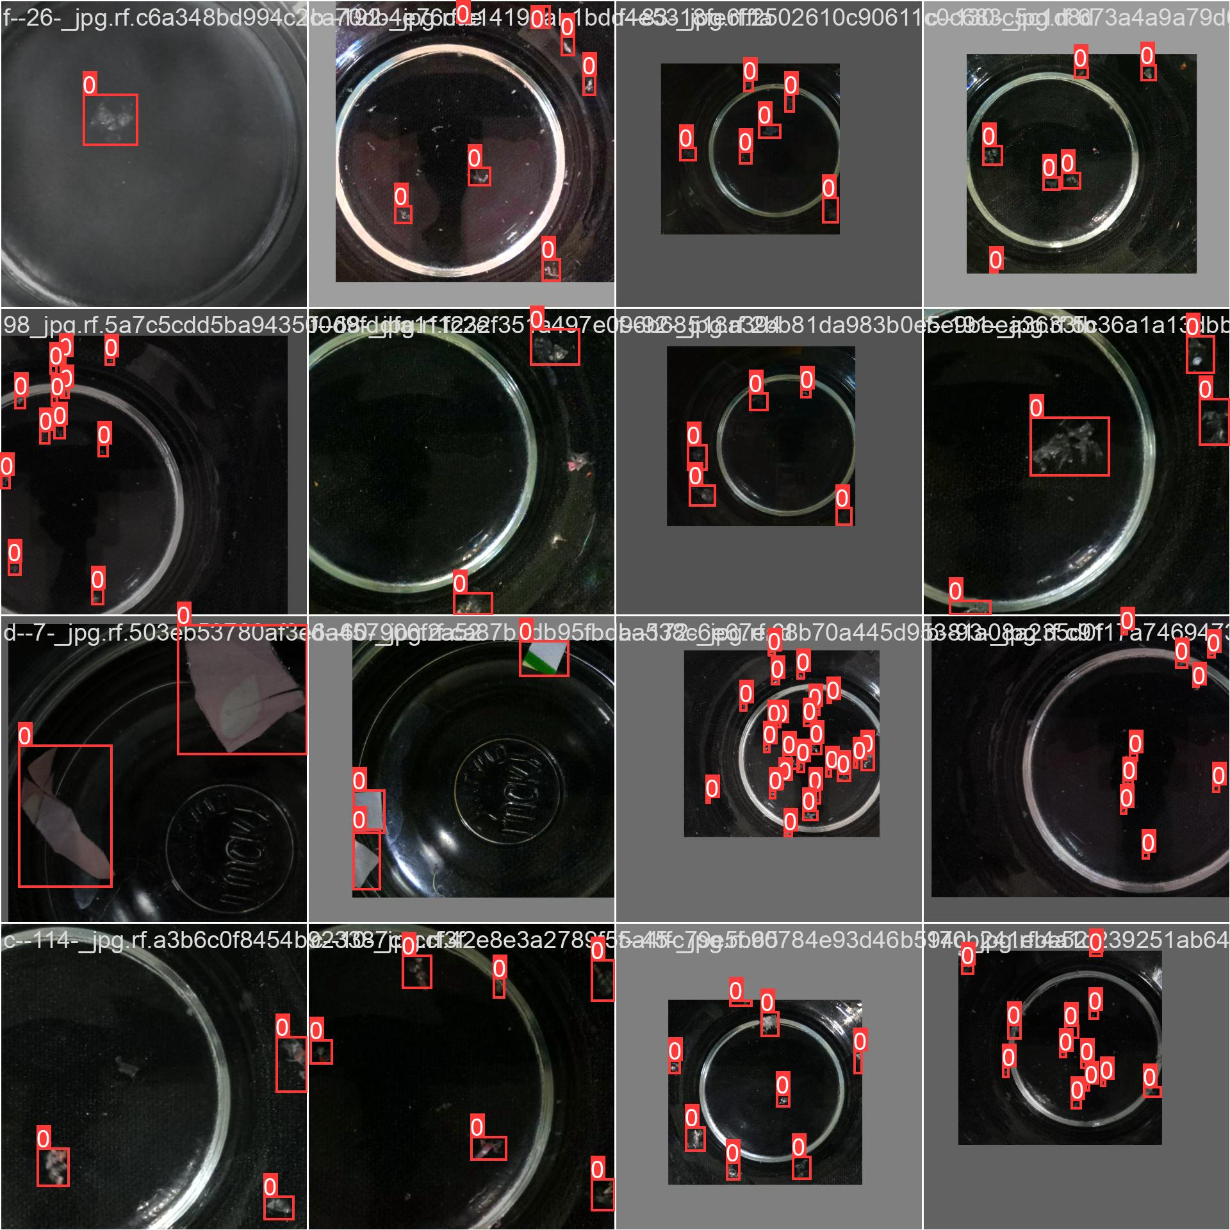
Figure 2. Training Image data
From the above we can see that the models performed exemplarily on the training image data It depicts how the model performed on the training data. The image size of the image was increased. The 0 in the image indicates the number of the class as indicated in the YAML file 0 represents micro-plastics class.
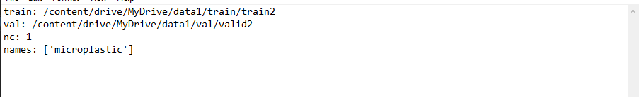
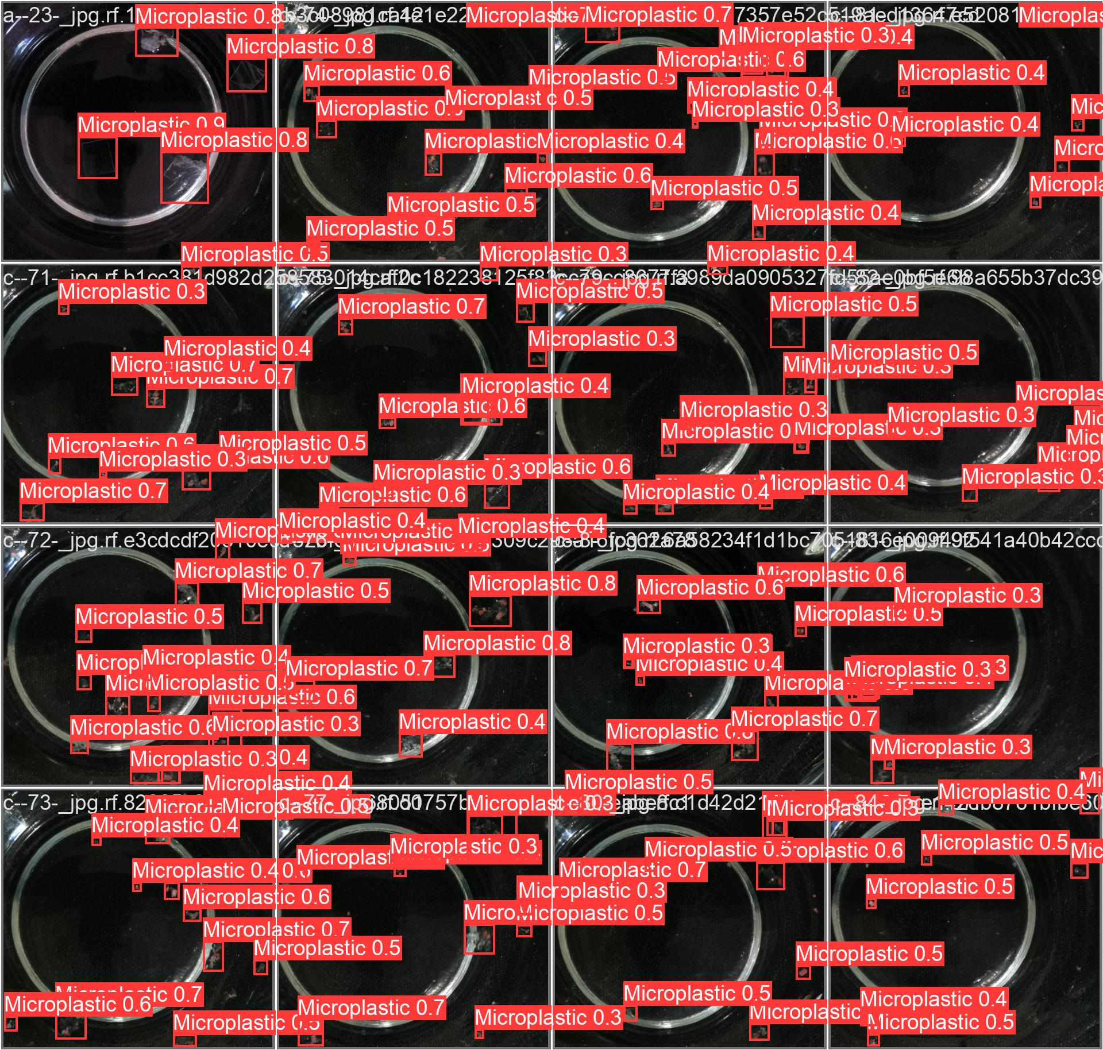

Figure 3 validation image data.
The above shows how the model was able to identify micro-plastic in a validation batch. The more increase in the training batch the more accurate detect objects. Batch size and image size increase performances increase with a shortcoming being the specifics of the GPU.

5. Conclusions
In the proposed model, the model performed well as the batch size and image size was increased. Due to the limited computation power of the computer the larger the batch size the high the computation power is needed. For future studies, with the use of computer with higher computation power will fit to increase the batch size which will significant increase the performance of the model. Also the model was limited to the amount of dataset provided and increase in the dataset and introducing varieties of the dataset will help the model to generalize on the input.
In the proposed model, data augmentation was only utilized in image transformation. Additional image transformation like fourier transform should be used in future to help the model to identify the objects with ease. Using other filter methods such as bileteral filter which is effective when preserving edges and performing noise reduction and smoothing.
YOLOv8 has proven to be efficient in detection of objects. One of the shortcoming of this algorithm is it does not perform well in detection of small objects in the image. Using ensemble approach by using additional libraries such as Slicing Aided Hyper Inference (SAHI) library which does localization and classification of small objects in an image.

References.
Rahimi, A., García, J. Chemical recycling of waste plastics for new materials production. Nat Rev Chem 1, 0046 (2017). https://doi.org/10.1038/s41570-017-0046.
· Roland Geyer et al. Production, use, and fate of all plastics ever made.Sci. Adv.3,e1700782(2017).DOI:10.1126/sciadv.1700782

Plastic sources: A survey across scientific and grey literature for their inventory and relative contribution to microplastics pollution in natural environments, with an emphasis on surface water. Luca Nizzetto, Pietro Volta.
Sajjad Abbasi, Naghmeh Soltani, Behnam Keshavarzi, Farid Moore, Andrew Turner, Mina Hassanaghaei,Microplastics in different tissues of fish and prawn from the Musa Estuary, Persian Gulf,Chemosphere,Volume 205,2018,Pages 80-87,ISSN 0045-6535,https://doi.org/10.1016/j.chemosphere.2018.04.076.
Massarelli, Carmine, Claudia Campanale, and Vito Felice Uricchio. 2021. "A Handy Open-Source Application Based on Computer Vision and Machine Learning Algorithms to Count and Classify Microplastics" Water 13, no. 15: 2104. https://doi.org/10.3390/w13152104

Deep learning approach for automatic microplastics counting and classification.Author links open overlay panelJavier Lorenzo-Navarro ª, Modesto Castrillón-Santana ª, Elena Sánchez-Nielsen ^{c}, Borja Zarco ª, Alicia Herrera ^{b}, Ico Martínez ^{b}, May Gómez . 2021

Crislaine Bertoldi, Larissa Z. Lara, Adriano A. Gomes, Andreia N. Fernandes,Microplastic abundance quantification via a computer-vision-based chemometrics-assisted approach,Microchemical Journal,Volume 160, Part B,2021,
DETECTION OF MICROPLASTICS USING MACHINE LEARNING ZENON CHACZKO1 , PETER WAJS-CHACZKO2 , DAVID TIEN3 , YOUSEF HAIDAR1, 2015
J. Lorenzo-Navarro et al., "SMACC: A System for Microplastics Automatic Counting and Classification," in IEEE Access, vol. 8, pp. 25249-25261, 2020, doi: 10.1109/ACCESS.2020.2970498.

Xinyu Yan, Zhi Cao, Alan Murphy, Yuansong Qiao,An ensemble machine learning method for microplastics identification with FTIR spectrum,Journal of Environmental Chemical Engineering,Volume 10, Issue 4,2022,
S. Wang, W. Liu, J. Wu, L. Cao, Q. Meng and P. J. Kennedy, "Training deep neural networks on imbalanced data sets," 2016 International Joint Conference on Neural Networks (IJCNN), Vancouver, BC, Canada, 2016, pp. 4368-4374, doi: 10.1109/IJCNN.2016.7727770. keywords: {Neural networks;Classification algorithms;Machine learning;Training;Standards;Sampling methods;Australia;deep neural network;loss function;data imbalance},
Ryu S-E, Chung K-Y. Detection Model of Occluded Object Based on YOLO Using Hard-Example Mining and Augmentation Policy Optimization. Applied Sciences. 2021; 11(15):7093. https://doi.org/10.3390/app11157093
Ekrem Kursad Dal, Recai Kilic. Design and Implementation of a Microplastic Detection and Classification System Supported by Deep Learning Algorithm, 24 January 2024, PREPRINT (Version 1) available at Research Square [https://doi.org/10.21203/rs.3.rs-3890356/v1]
Neural Network Analysis for Microplastic Segmentation by Gwanghee Lee andKyoungson Jhang. 2021
Machine learning: Next promising trend for microplastics study.Author links open overlay panelJiming Su ª, Fupeng Zhang ^{b}, Chuanxiu Yu ª, Yingshuang Zhang ^{c}, Jianchao Wang ^{d}, Chongqing Wang ^{e}, Hui Wang ª, Hongru Jiang ª
Automatic quantification and classification of microplastics in scanning electron micrographs via deep learning.Author links open overlay panelBin Shi ª, Medhavi Patel ^{b}, Dian Yu ª, Jihui Yan ª, Zhengyu Li ^{c}, David Petriw ª, Thomas Pruyn ª, Kelsey Smyth ^{d}, Elodie Passeport ^{b} ^{d}, R.J. Dwayne Miller ^{e}, Jane Y. Howe ª ^{b}Volume 344, 15 October 2023, 118756

*

